Student Name: Azamat Salamatov

Professor Cleveland

COMP 3324 - 1

Week 5 – Lab 1 – Web Goat Secure Application

February 28, 2023,

Web Goat Secure Application

# Web Goat website and tamper data

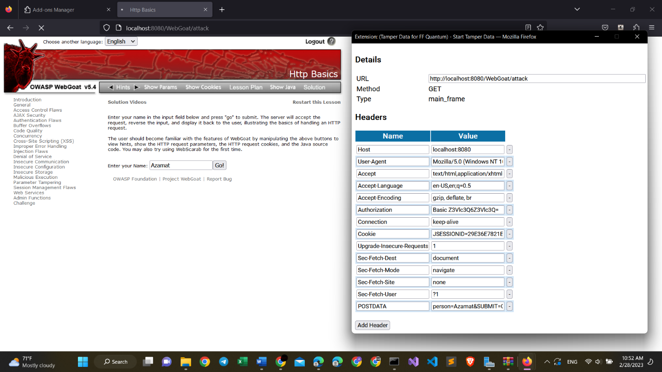

*Web Goat Security Application – Azamat Salamatov*

# Tomcat Java application

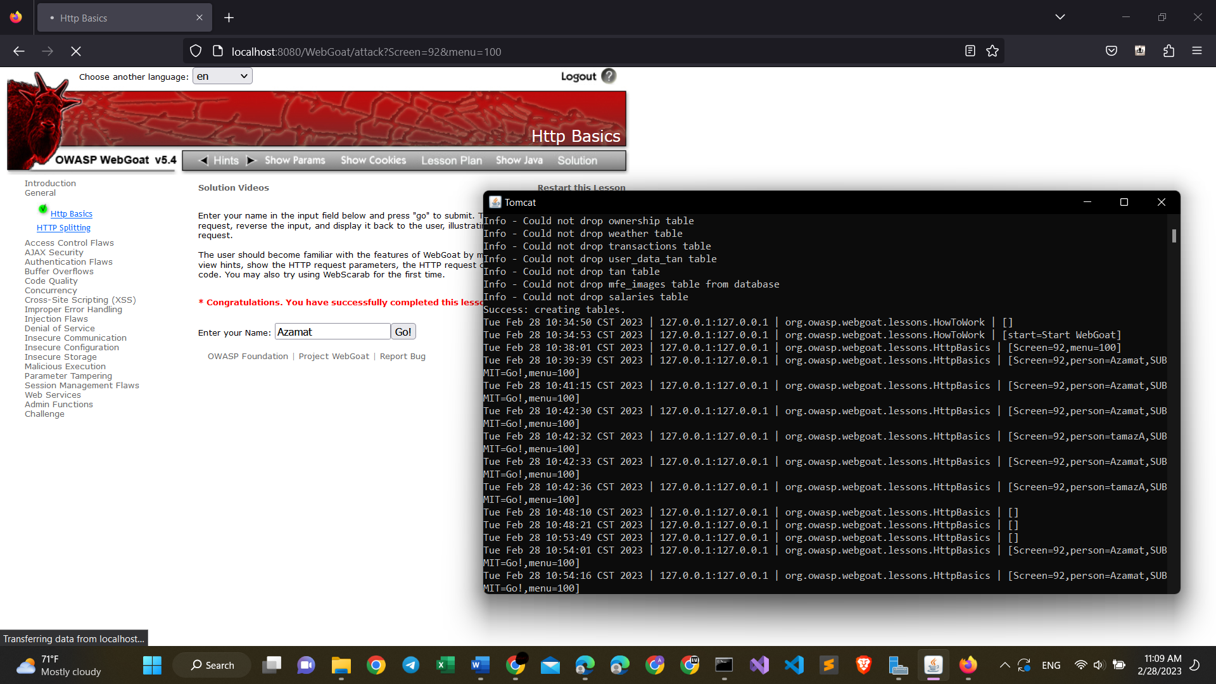

*Tomcat java application*

# My summary on Web Goat Security Application

* While doing this assignment I have come across some challenges:
* First, on new versions of fire fox tamper data add-n does not display on the java tools.
* That is why I used Tamper Data for FF Quantum. It also worked fine.
* Next, after working with Web Goat application I saw some changes on the tomcat application as you can see above, all my actions were recorded on this java project.